Steps to upload editorials to the newsroom of the www.scientificgames.com website

Login to Umbraco CMS
Please login to Umbraco CMS using below link and your credentials
http://admin.scientificgames.com/umbraco#
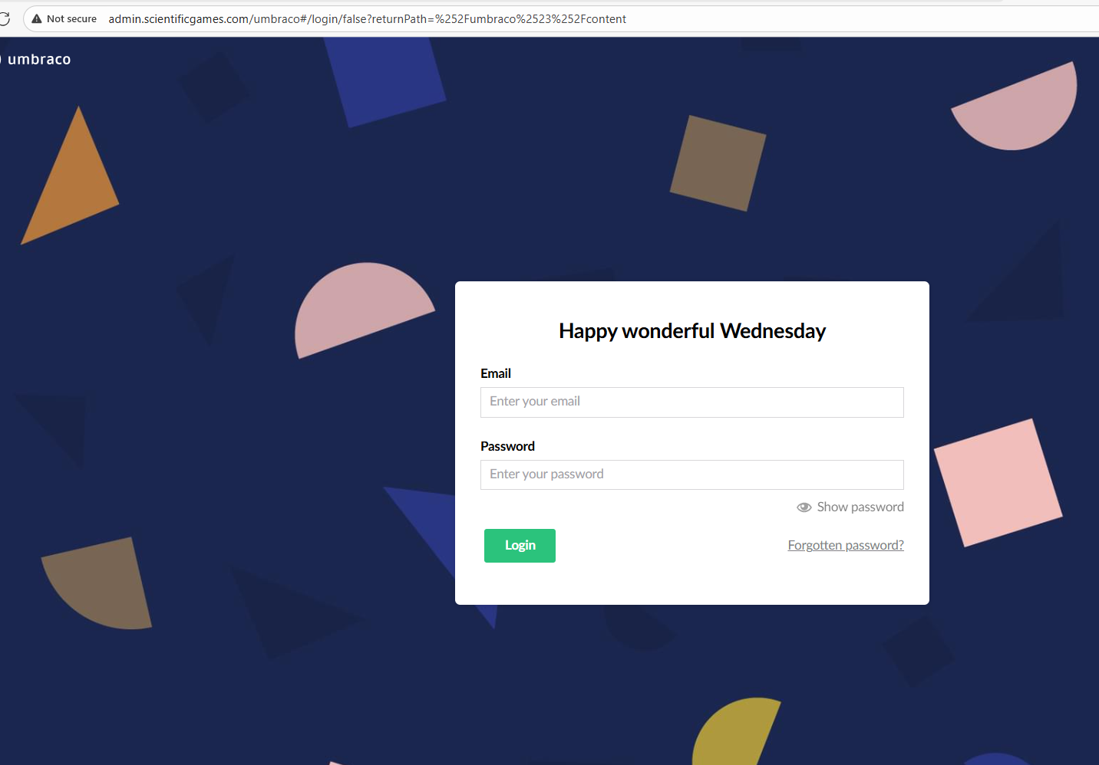

After Successful login – Please go to News (Under Home) at left hand side of the screen
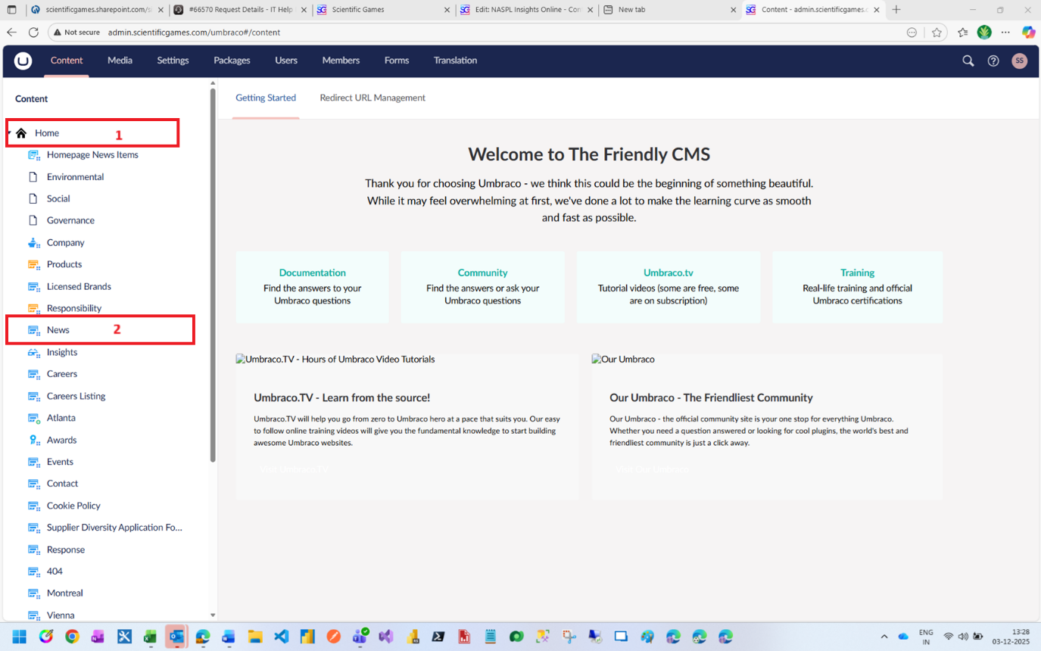

Now click on News Article section
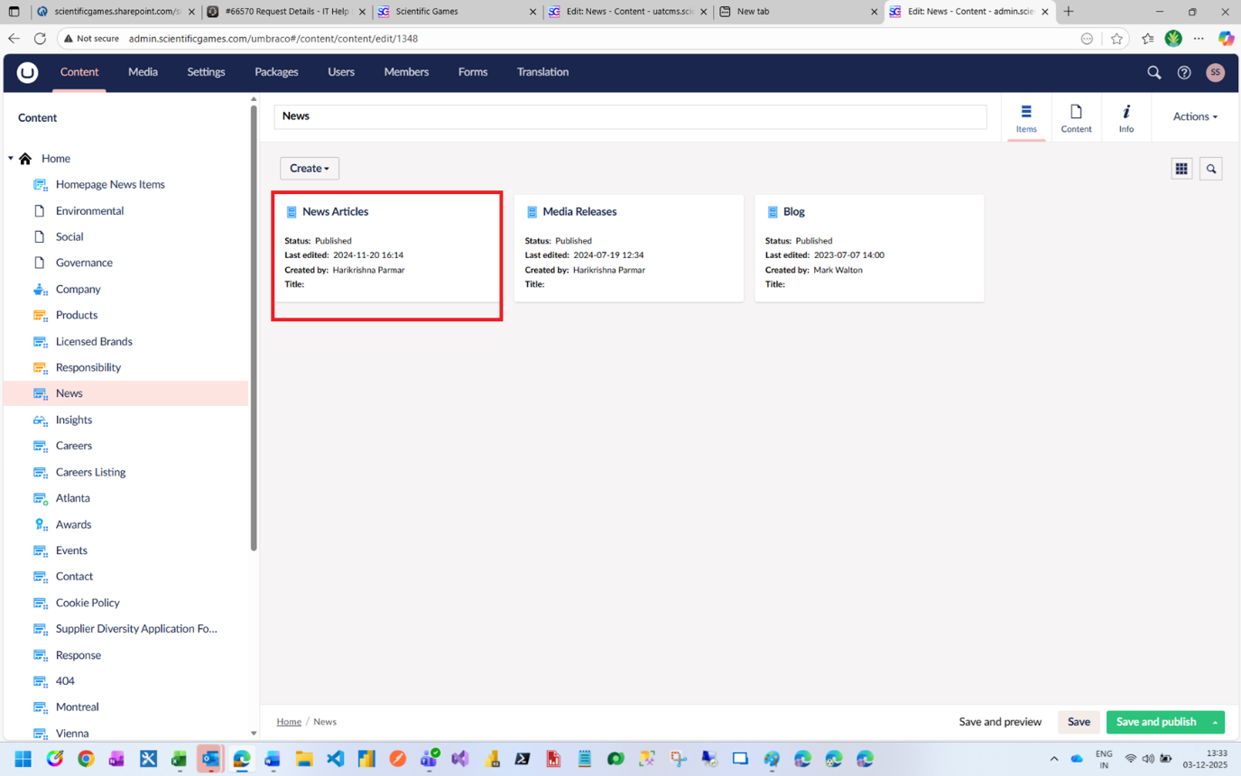

Click on Create News Item
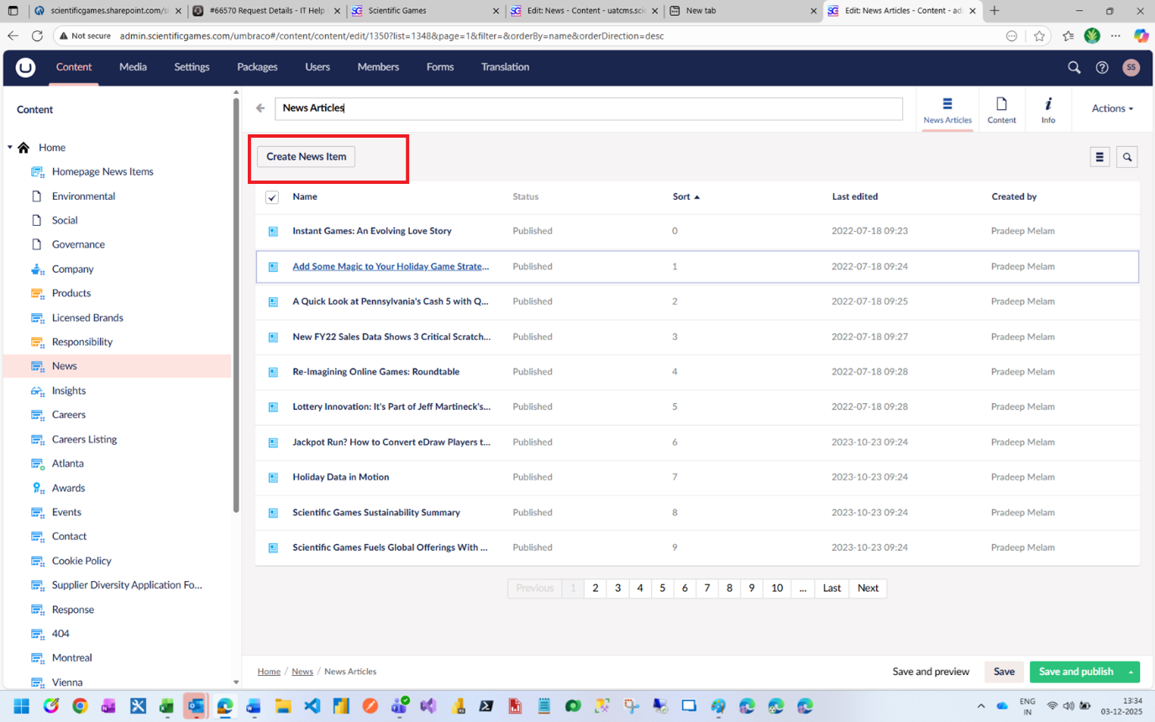

A new Form will appear, please fill all the required fields and click on “Save and Publish”
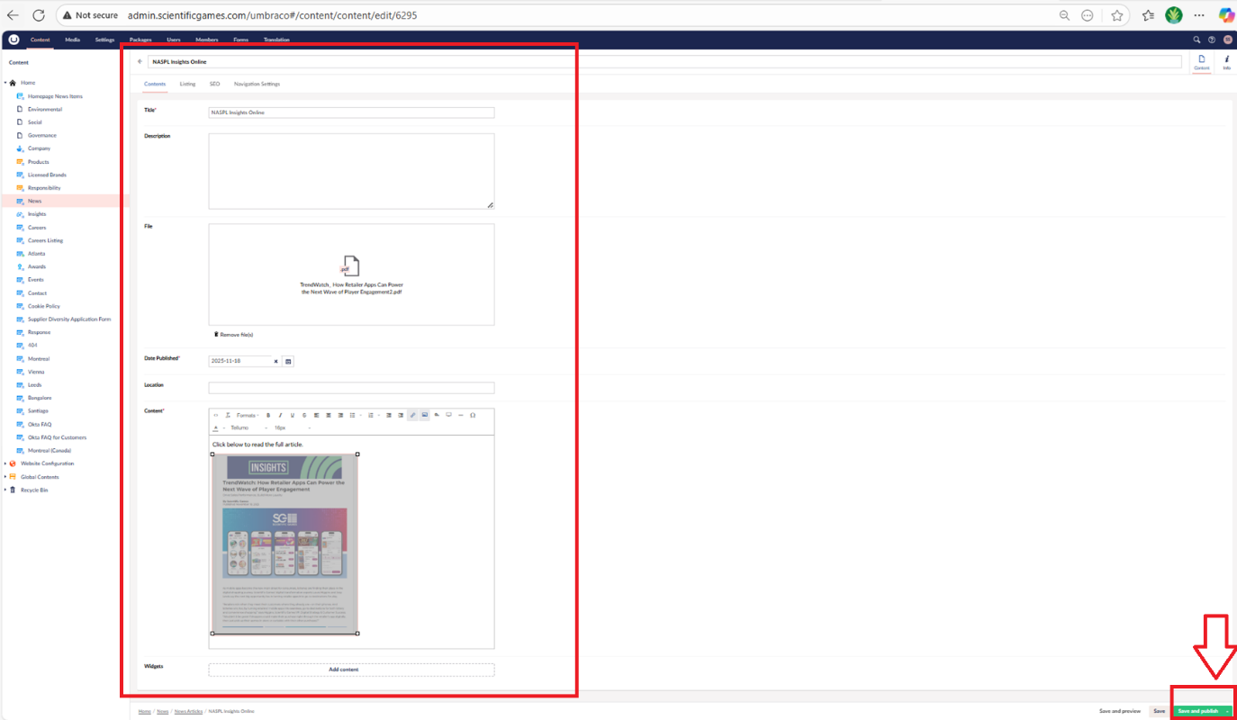

Please verify newly uploaded item in news page
